Emmeans alternative - PP66 FM3.0

Valerie Martin

10/7/2019

## Skypilot Selection Analyse with 66% Pollination Percentage and 3.0 Seed Maturity

### Supplementation Experiment

Niki: “Can’t use cumberland pass (no supplmement seeds were successfully collected…triple checking that). Marginal interaction effect: total seeds per plant increased with supplementation of skunky, but not sweet, flowers. Sweet has this weird relationship where sup seedset goes up with flower size. Jake swears size differences shouldn’t have influenced the effectiveness of the treatment.”

#### Sweet morph only

Niki: “no effect of habitat => remove no treatment effect, but Candi saw this in some years - might it relate to weaking selection?”

Niki: “Extract least squares mean which accounts for random effect”

fit<-lme(sqrt(Total.SeedsPerPlant)~Treatment, random=~1|Site, data=fruit.sw.np, method="ML", na.action=na.omit)   
anova.lme(fit)

## numDF denDF F-value p-value  
## (Intercept) 1 37 224.12058 <.0001  
## Treatment 1 37 1.19898 0.2806

#type="response" causes the emmeans and contrasts tables to backtransform from the sqrt and show confidence intervals and p-values that represent the backtransformed variables  
marginal = emmeans(fit, specs=pairwise ~ Treatment, type = "response")  
marginal$emmeans

## Treatment response SE df lower.CL upper.CL  
## Natural 40.9 6.79 1 0 173  
## Supplementation 30.3 6.79 1 0 178  
##   
## d.f. method: containment   
## Confidence level used: 0.95   
## Intervals are back-transformed from the sqrt scale

marginal$contrasts

## contrast estimate SE df t.ratio p.value  
## Natural - Supplementation 0.891 0.813 37 1.095 0.2806

marginal$contrasts %>%  
 summary(infer = TRUE)

## contrast estimate SE df lower.CL upper.CL t.ratio  
## Natural - Supplementation 0.891 0.813 37 -0.757 2.54 1.095   
## p.value  
## 0.2806   
##   
## Confidence level used: 0.95

#putting the data into a data frame so that we can plot it  
marginal_contrasts = marginal$contrasts %>%  
 summary() %>%  
 as.data.frame()  
marginal_contrasts

## contrast estimate SE df t.ratio p.value  
## 1 Natural - Supplementation 0.890664 0.813406 37 1.094981 0.2806019

marginal_sqrt = emmeans(fit, specs=pairwise ~ Treatment)  
#plot of the sqrt transformed emmeans  
plot(marginal_sqrt, xlab="Estimated marginal means")

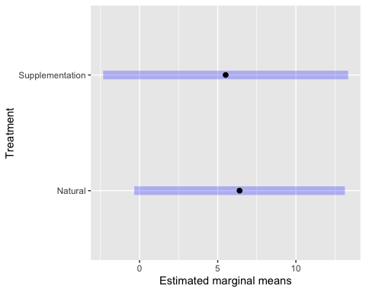

Plots (not controlling for random effects)

ggplot(fruit.sw.np, aes(Treatment,Total.SeedsPerPlant)) +  
 geom_violin(fill='gray') +  
 geom_dotplot(binaxis='y', stackdir='center', dotsize=1) +  
 facet_wrap(~Morph) +  
 scale_y_continuous(trans="sqrt") +  
 ylab("Seeds per plant") +  
 xlab("Morph") +  
 theme_bw() +  
 theme(panel.grid.major = element_blank(), panel.grid.minor = element_blank(), text = element_text(size=18))

## `stat_bindot()` using `bins = 30`. Pick better value with `binwidth`.

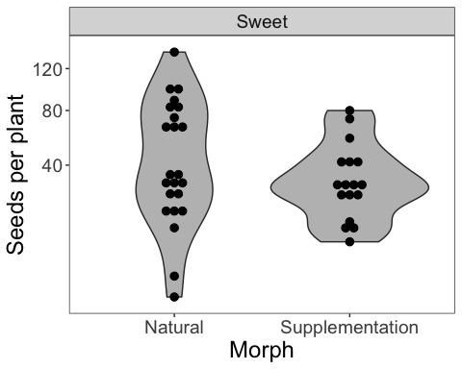

ggplot(fruit.sw.np, aes(Treatment,Total.SeedsPerPlant)) +  
 geom_boxplot() +   
 scale_y_continuous(trans="sqrt") +  
 ylab("Seeds per plant") +  
 xlab("Morph") +  
 theme_bw() +  
 theme(panel.grid.major = element_blank(), panel.grid.minor = element_blank(), text = element_text(size=18))

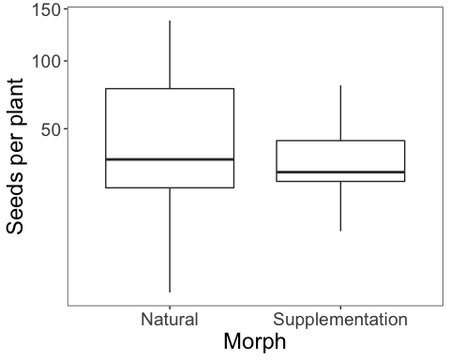

With habitat effects: Val: “For the two second ANOVA tables, I am getting an error regarding the use of lm() instead of lme() - why are we using lm() and why is it not computing into an ANOVA table?”

fit<-lme(sqrt(Total.SeedsPerPlant)~Treatment, random=~1|Site/Habitat, data=fruit.sw.np, method="ML", na.action=na.omit)   
anova.lme(fit)

## numDF denDF F-value p-value  
## (Intercept) 1 35 224.11952 <.0001  
## Treatment 1 35 1.19899 0.281

fit<-lm(sqrt(Total.SeedsPerPlant)~Habitat, data=fruit.sw.np)  
  
fit<-lme(sqrt(Total.SeedsPerPlant)~Treatment*Habitat, random=~1|Site, data=fruit.sw.np, method="ML", na.action=na.omit)   
anova.lme(fit)

## numDF denDF F-value p-value  
## (Intercept) 1 35 227.82576 <.0001  
## Treatment 1 35 1.21880 0.2771  
## Habitat 1 35 2.13940 0.1525  
## Treatment:Habitat 1 35 0.48882 0.4891

fit<-lm(sqrt(Total.SeedsPerPlant)~Site, data=fruit.sw.np)

Both Morphs

fit<-lme(sqrt(Total.SeedsPerPlant)~Treatment*Morph, random=~1|Site, data=fruit.np, method="ML", na.action=na.omit)   
anova.lme(fit)

## numDF denDF F-value p-value  
## (Intercept) 1 64 421.9551 <.0001  
## Treatment 1 64 0.0489 0.8257  
## Morph 1 64 0.4053 0.5266  
## Treatment:Morph 1 64 3.6884 0.0593

marginal_both = emmeans(fit, specs=pairwise ~ Treatment, type = "response")

## NOTE: Results may be misleading due to involvement in interactions

marginal_both$emmeans

## Treatment response SE df lower.CL upper.CL  
## Natural 36.6 5.03 1 0.607 128  
## Supplementation 40.2 5.72 1 0.366 146  
##   
## Results are averaged over the levels of: Morph   
## d.f. method: containment   
## Confidence level used: 0.95   
## Intervals are back-transformed from the sqrt scale

marginal_both$contrasts

## contrast estimate SE df t.ratio p.value  
## Natural - Supplementation -0.287 0.613 64 -0.468 0.6413   
##   
## Results are averaged over the levels of: Morph

marginal_both_sqrt = emmeans(fit, specs=pairwise ~ Treatment)

## NOTE: Results may be misleading due to involvement in interactions

marginal_both$contrasts %>%  
 summary(infer = TRUE)

## contrast estimate SE df lower.CL upper.CL t.ratio  
## Natural - Supplementation -0.287 0.613 64 -1.51 0.938 -0.468   
## p.value  
## 0.6413   
##   
## Results are averaged over the levels of: Morph   
## Confidence level used: 0.95

#putting the data into a data frame so that we can plot it  
marginal_contrasts2 = marginal_both$contrasts %>%  
 summary() %>%  
 as.data.frame()  
marginal_contrasts2

## contrast estimate SE df t.ratio p.value  
## 1 Natural - Supplementation -0.2870732 0.613242 64 -0.4681238 0.6412864

#plot of the sqrt transformed emmeans  
plot(marginal_both_sqrt, xlab="Estimated marginal means")

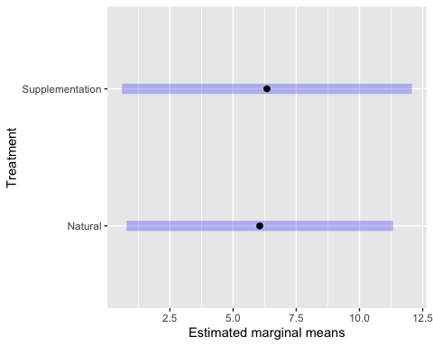

plot (not controlling for random effects)

ggplot(fruit.sm, aes(Treatment,Total.SeedsPerPlant)) +  
 geom_boxplot() +   
 scale_y_continuous(trans="sqrt") +  
 ylab("Seeds per plant") +  
 facet_wrap(~Morph) +  
 theme_bw() +  
 theme(panel.grid.major = element_blank(), panel.grid.minor = element_blank(), text = element_text(size=18))

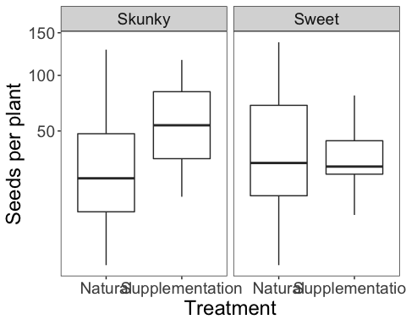

with habitat effects:

fit<-lme(sqrt(Total.SeedsPerPlant)~Treatment*Habitat, random=~1|Site, data=fruit.np, method="ML", na.action=na.omit)   
anova.lme(fit)

## numDF denDF F-value p-value  
## (Intercept) 1 64 289.18502 <.0001  
## Treatment 1 64 0.02835 0.8668  
## Habitat 1 64 1.27081 0.2638  
## Treatment:Habitat 1 64 1.88813 0.1742